**BMI Calculator**

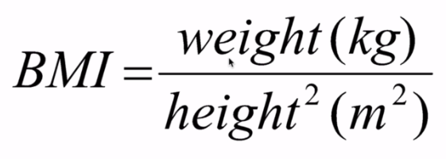

var weight = prompt("Enter weight in kg: ");

var height = prompt("Enter height in metern(m): ");

//BMI Calcutor Function

function BMI(weight, height){

bmi = Math.ceil(weight/(height*height));

console.log("BMI = "+bmi+"kg/m^2");

}

//Function Call

BMI(weight,height);

**BMI = 21kg/m^2**

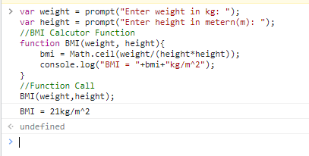

**Method 2:**

Use Power Function

var weight = prompt("Enter weight in kg: ");

var height = prompt("Enter height in metern(m): ");

//BMI Calcutor Function

function BMI(weight, height){

bmi = Math.ceil(weight/Math.pow(height,2)); //Math.Pow(variable whose power is to be calculate, how much pwer like sqare (2), cube (3))

console.log("BMI = "+bmi+"kg/m^2");

}

//Function Call

BMI(weight,height);

**BMI = 21kg/m^2**

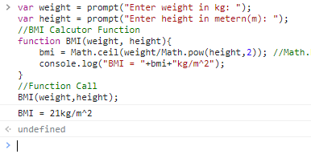

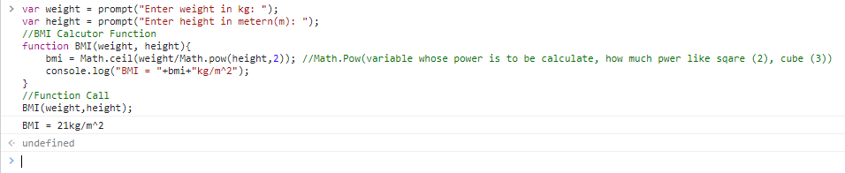

<https://developer.mozilla.org/en-US/docs/Web/JavaScript/Reference/Global_Objects/Math/pow>

**Math.pow()**

The **Math.pow()** static method, given two arguments, *base* and *exponent*, returns baseexponent.

console.log(Math.pow(7, 3));

// expected output: 343

console.log(Math.pow(4, 0.5));

// expected output: 2

console.log(Math.pow(7, -2));

// expected output: 0.02040816326530612

// (1/49)

console.log(Math.pow(-7, 0.5));

// expected output: NaN

[**Syntax**](https://developer.mozilla.org/en-US/docs/Web/JavaScript/Reference/Global_Objects/Math/pow#syntax)

Math.pow(base, exponent)

### [Parameters](https://developer.mozilla.org/en-US/docs/Web/JavaScript/Reference/Global_Objects/Math/pow#parameters)

base

The base number.

exponent

The exponent used to raise the base.

### [Return value](https://developer.mozilla.org/en-US/docs/Web/JavaScript/Reference/Global_Objects/Math/pow#return_value)

A number representing the given base taken to the power of the given exponent.

## [Description](https://developer.mozilla.org/en-US/docs/Web/JavaScript/Reference/Global_Objects/Math/pow#description)

The **Math.pow()** function returns the base to the exponent power, as in baseexponent, the base and the exponent are in decimal numeral system.

Because pow() is a static method of Math, use it as Math.pow(), rather than as a method of a Math object you created. (Math has no constructor.) If the base is negative and the exponent is not an integer, the result is NaN.

[**Examples**](https://developer.mozilla.org/en-US/docs/Web/JavaScript/Reference/Global_Objects/Math/pow#examples)

[**Using Math.pow()**](https://developer.mozilla.org/en-US/docs/Web/JavaScript/Reference/Global_Objects/Math/pow#using_math.pow)

// simple

Math.pow(7, 2); // 49

Math.pow(7, 3); // 343

Math.pow(2, 10); // 1024

// fractional exponents

Math.pow(4, 0.5); // 2 (square root of 4)

Math.pow(8, 1/3); // 2 (cube root of 8)

Math.pow(2, 0.5); // 1.4142135623730951 (square root of 2)

Math.pow(2, 1/3); // 1.2599210498948732 (cube root of 2)

// signed exponents

Math.pow(7, -2); // 0.02040816326530612 (1/49)

Math.pow(8, -1/3); // 0.5

// signed bases

Math.pow(-7, 2); // 49 (squares are positive)

Math.pow(-7, 3); // -343 (cubes can be negative)

Math.pow(-7, 0.5); // NaN (negative numbers don't have a real square root)

// due to "even" and "odd" roots laying close to each other,

// and limits in the floating number precision,

// negative bases with fractional exponents always return NaN

Math.pow(-7, 1/3); // NaN